**Alamouti Code**

Felix Liu, Shuihan Liu and Mohamed Ibrahim

Electrical & Computer Engineering, Purdue University

VIP 47920: Beyond 5G

Prof. [Chih-Chun Wang](https://engineering.purdue.edu/~chihw/)

**TABLE OF CONTENTS**

ABSTRACT……………………………………………………………………………....…...3

1. Continuous Challenge of Wireless Communication …...………………………..……4

1.1 The Challenge: Fading…………....………………………………………4

1.2 The Approach: Antenna Diversity .……………………………………….4

2. Space-Time Block Codes (STC) ……………………………………….………..……5

3. Alamouti code ………………………..………………………………..……………...5

3.1 An Outline of Alamouti Code...…………………….…...…………….….6

3.2 Comparative Bit Error Rate Plots ……………………...……………..….6

3.3 Advantages of Alamouti Code ...………………………...…………....….7

REFERENCES ……………………………………………………………………....………..9

**ABSTRACT**

As fading continues to be a challenge in wireless communication technologies, many design schemes and approaches have been tried and analyzed in their ability to mitigate this problem. One such approach is through increasing the number antennas on either the receiver or transmitter sides. Utilizing this approach, space-time block coding, and more specifically, Alamouti codes, have been shown to greatly reduce effects of fading. In this paper, the basic scheme of space time block coding will be introduced. In section 3, the Alamouti coding, a simple MISO technique that can be used to reduce the BER of a system, at a specific SNR, without any loss on the data rate will be introduced. Furthermore, we will also mention some detail of Alamouti coding such as its orthogonal design, Alamouti scheme, BER (bit error rate) simulation, the advantages of Alamouti code and its application.

**1. Continuous Challenge of Wireless Communication**

Even as wireless communications become more advanced and more powerful, the goal remains to strive for continuous improvements in transmitting rates while remaining economical. Reliability in transmitting data through diverse environments still remains a challenge due to various obstacles and physical phenomena. However, many developments, such as Alamouti code, have helped to lessen the impacts of these obstacles in wireless communications. This paper aims to define and analyze Alamouti code and investigate the practicality of the schemes.

**1.1. The Challenge: Fading**

In order to understand Alamouti code, there are various terminologies to define to set the context for its importance. Between the receiver and transmitter of a wireless communication system, there is often no direct link due to physical obstacles, and this causes the signal to be reflected in various ways that a distorted signal is received. A transmitted signal is often reflected and attenuated in a wireless channel, and relative movements of the transmitter and receiver will also negatively impact the quality of the received signal. The term for this phenomenon is known as multipath fading. As it is difficult to predict this, it is often modelled as time-varying random variables.

**1.2. The Approach: Antenna Diversity**

Due to the effects of multipath fading, it can be seen that a single input single output (SISO) scheme would not work very efficiently. As there is only one receiver and transmitter, the interference on the signal could cause it to be extremely different from the transmission, meaning data is being lost. Other events could also cause the receiver to not receive the transmission, and the single link between the receiver and transmitter would be lost. Solutions to combat this issue are to increase the number of receivers, called receive diversity, or to increase the number of transmitters, known as transmit diversity. Collectively, increasing either is called antenna diversity, and it establishes multiple links between the transmitter and receiver[1]. As fading alters some of the received signals, the other transmissions will be cleaner due to mitigate fading effects, and the transmitted signal can be decoded from these cleaner receptions.

**2.** **Space-Time Block Codes (STC)**

Antenna diversity is the basic principle for multiple input multiple output (MIMO) wireless communication schemes. Within MIMO systems, diversity is achieved with antennas at the transmitter side transmitting the same information but at different time slots. This is known as space-time codes (STCs), which can be further divided into two categories: space-time block codes (STBCs) and space-time trellis codes (STTCs). STTCs have better performance than STBCs, but they are also more complex[2]. Alamouti coding schemes are STBCs, so the nuances of the STTCs will not be discussed.

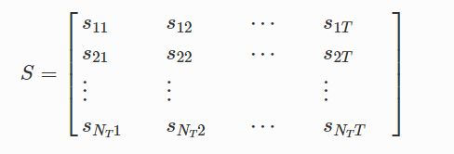

Figure 2.1. Code matrix representing STBC transmit antenna transmissions over time.[2]

Transmissions of an STBC can be represented with a matrix, shown in the figure above. Each row in the matrix represents an antenna on the transmitter side, with each column representing a time slot. S represents the symbols to which information has been encoded[2]. In general, a specific value in the matrix is one symbol transmitted by one antenna on the transmitter side at a specific instance in time. These matrices are usually designed to have orthogonality so that decoding at the receiver end is simpler, but this sacrifices part of its data rate[2].

**3.** **Alamouti code**

**3.1: An outline of Alamouti Code**

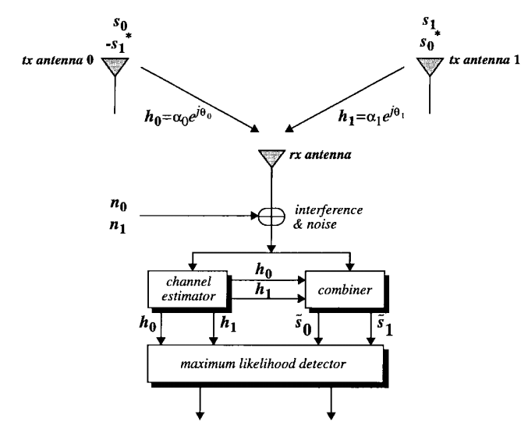

Fig.3.1: An illustration of a 2x1 MISO system [1]

Siavash Alamouti outlined in 1998 a technique for achieving transmit diversity which later came to be named as ‘Alamouti Code’ [1]. Alamouti code has a coding matrix C where C is given by

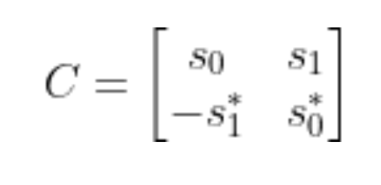

where s0 denotes the symbol transmitted by antenna 0 at the first transmit instant and s1 denotes the symbol transmitted by antenna 1 at the first transmit instant. In deriving a set of mathematical expressions that illustrate outline the details of the received signals and the combining scheme used in alamouti code, the following assumptions are made:

1－ The receiver has perfect knowledge of the channel coefficients.

2 - For a sufficiently small transmit symbol period T, we can assume that the time varying function h(t) has a constant value between two consecutive symbol transmissions such that

h(t) = h(t + T) (1)

where h(t) is complex multiplicative factor that is given by,

h(t) = $αe^{jθ}$ (2)

3 - Given that the transmitter has available symbol transmission power P, we choose to split the transmit power P evenly across each antenna such that the effective power per symbol is equal to $\frac{P}{2}$.

Given these assumptions, suppose we use the scheme outlined by the matrix C to transmit a two symbol message {s0, s1}. We can express the received symbol at the first transmit instant r0 as,

r0 = h0s0 + h1s1 +n0 (3)

where h0 describes the channel coefficient of the channel between antenna 0 and the receiver, h1 describes the channel coefficient of the channel between antenna 1 and the receiver, and n0 is a noise value generated at the received by Additive White Gaussian Noise (AWGN).

Similarly, the received symbol at the second transmit instant r1 can be given by,

r1 = -h0s1* + h1s0* +n1 (4)

Now, given the following expressions for r0 and r1, we would like to come up with a combining scheme that would allow us to make the best possible decision, using a maximum likelihood decoder, on what the values of the transmitted symbols were given the available information. Alamouti defines the following combination scheme [1],

s0’ = h0*r0 + h1r1*

s1' = h1*r0 - h0r1* (5)

Substituting (3), (4) into (5), we yield the following expressions for s0’

s0’ = (s0 + h0*n0 + h1n1* s1’ = (s0 + h0n1* + h1*n0 (6)

Symbols s0’ and s1’ are then passed through a maximum likelihood decoder. As illustrated by Alamouti [1], the expression for symbol s0’ is identical to that of the effective decision symbol in a maximum receive ratio combining (MRRC) scheme [1]. s1’ features phase rotations on its last two terms but those however do not degrade the effective signal-to-noise ratio (SNR). This therefore shows that the resulting diversity order of the Alamouti transmit diversity scheme for a 2x1 system is equivalent to that of 1x2 MRRC.

**3.2: Comparative Bit Error Rate Plots**

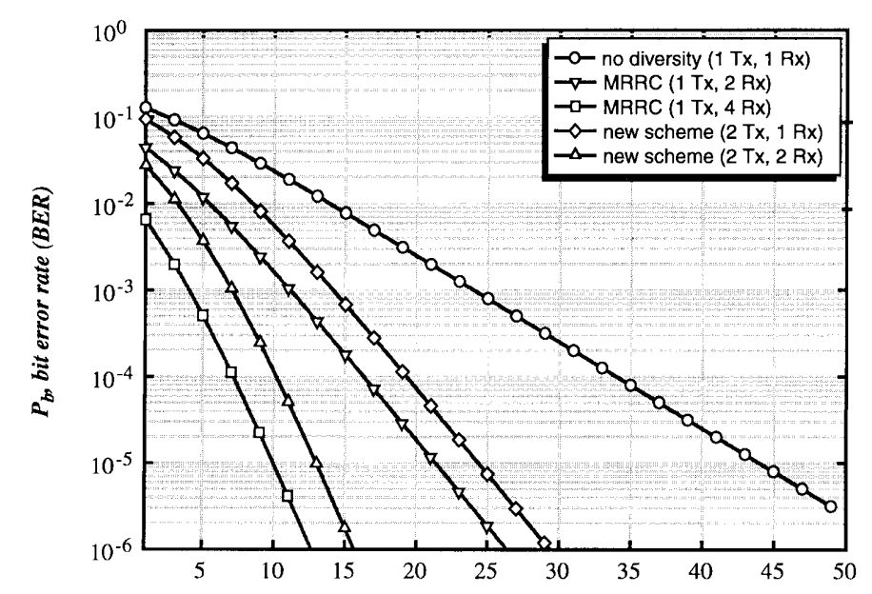

Fig 3.2.1: Bit Error Rate Plots of Alamouti Code (new scheme) and MRRC using a BPSK modulation scheme in a Rayleigh Fading Channel

Fig. 3.2.1 illustrates the bit error rate performance when using Alamouti’s transmit diversity scheme. At first glance, it may seem that the performance of this scheme does not match the performance of that equivalent of an equivalent MRRC with the same number of antennas. However, the difference in the bit error rate plots is attributed to the fact that we assumed that the effective SNR per symbol is halved due to the transmit power per symbol being halved in Alamouti’s scheme. This results in a -3dB difference in the bit error rate plots as shown above, which is an acceptable difference as far as practical implementation is concerned. Nevertheless, we can clearly see that as the gradient of the new scheme plots and the respective MRRC plots are the same for higher SNR values, it can be deduced that Alamouti’s transmit diversity scheme achieves the same diversity order as MRRC.

**3.3** **Advantages of Alamouti code**

As we have introduced the scheme and performance of the Alamouti code, in this section, we will list the advantages of the Alamouti code and compare MIMO with SISO.

SISO (single input single output) only transmits one stream of data at one time, but MIMO can transmit multiple data simultaneously. In that way, using a SISO system would cause twice as much time compared to using a MIMO system with Alamouti code. Because MIMO technology can have both transmitter side and receiver side has multiple antennae so the transmitter can send multiple same data streams and the receiver can hear the same multiple signals, which improves the reliability of the data transmitting system and maintains the efficiency of the transmission process.

Data is encoded using a STBC and the encoded data is divided into *n* streams which are simultaneously transmitted using *n* transmit antennas. STBCs are invented to achieve the maximum diversity gain of transmitting and receiving antennas with the constraint of having a simple decoding algorithm. Specific STBCs designed for 2-4 transmit antennas perform extremely well in slow fading environments such as indoor transmission. The bandwidth efficiency of these codes is about 3-4 times those of previous systems.[3] Alamouti Code has also been shown an orthogonal rate-1 space-time block code, a commonly desired property among STBC [4].

**REFERENCES**

[1]: S. M. Alamouti, “A simple Transmit Diversity Technique for Wireless Communications,” *IEEE J. Select. Areas Commun*., vol. 16, pp. 1451–1458, Oct. 1998

[2]: K. D. Rao, “Space-Time Coding,” *Channel Coding Techniques for Wireless Communications Forum for Interdisciplinary Mathematics*, pp. 423–463, 2019.

[3]: V. Tarokh, H. Jafarkhani and A. R. Calderbank, "The application of orthogonal designs to wireless communication," *1998 Information Theory Workshop (Cat. No.98EX131)*, Killarney, Ireland, 1998, pp. 46-47, doi: 10.1109/ITW.1998.706408.

[4]: V. Tarokh; N. Seshadri and A. R. Calderbank. "Space–time codes for high data rate wireless communication: Performance analysis and code construction". *IEEE Transactions on Information Theory*. vol. 10. pp 744-765, 1998.